JOGAMAYA MEMORIAL INSTITUTE

Class:KG

Sub: ENG.

Q.1 | Write A to Z
Q.2. | After letter.
 | S |  |  |  | F |  |  |  |  |  | O
 | U |  |  |  | I |  |  |  |  |  | L
 | C |  |  |  | M |  |  |  |  |  | R
 | X |  |  |  | W |  |  |  |  |  | Q

Q.3 | Fill in the blanks with have or has
 | a) | I |  | a pen.
 | b) | You |  | a book.
 | c) | He |  | a car.
 | d) | She |  | a doll
 | e) | They |  | Colours
Q. 4 | Fill in the blank with am, is, are
 | a) | I |  | a teacher.
 | b) | You |  | a farmer.
 | c) | He |  | a doctor.
 | d) | She |  | nurse.
Q.5 | Write A/An
 | a) |  | ant.
 | b) |  | bat.
 | c) |  | ink - pot.
 | d) |  | owl.
 | e) |  | egg.
Q. 6 | Fill in the blanks with "This" or "That"
 | a) |  | is a tree. | 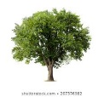
 | b) |  | is a tree.
 | c) |  | is a balloon. | 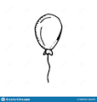
 | d) |  | is a balloon.

Q.7 Fill in the blanks with ‘This’ or ‘These’

- ………………………………… is a mango. 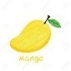

- …………………………………. Are mangoes.

- …………………………………. is a ball.

- …………………………………. are balls.

Q.8) Write the before letter

- …………….. C f) ……………… S
- …………….. E g) …………….. O
- …………….. X h) …………….. R
- …………….. M i) .……………. Q
- …………….. Y
- …………….. B
- …………….. T

Q.9) Write the names of the following body parts.

a)
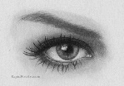 ………………………………. .

b)
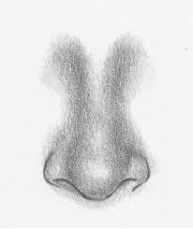 ………………………………… .

c)
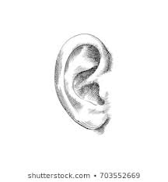 ………………………………….. .

d)
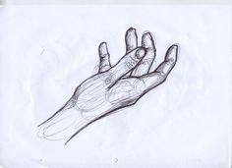 …………………………………. .

e)
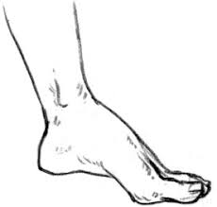 ……………………………….. .

Q.10) Fill in the blanks with the name of seasons.

- ……………………………………….. is hot season.

- ……………………………………….. is wet season.

- ……………………………………….. is cold season.

- ……………………………………….. is green of all seasons.

Q.11) Write the names of the festivals.

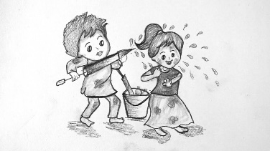 ………………………………………………………. .

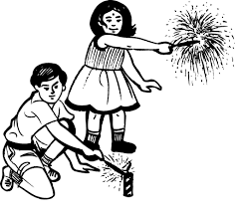 …………………………………………………….. .

c)
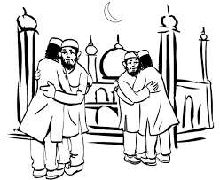 ……………………………………………………….. .

d)
……………………………………………………….. .

Q.12) Fill in the blank with the name of social helpers.

- …………………………………………. teaches us.
- …………………………………………. treats sick people.
- …………………………………………. protect us.
- …………………………………………. mends our shoes.
- …………………………………………. cut our hair.

Q.13) Look at the pictures and write what is it.

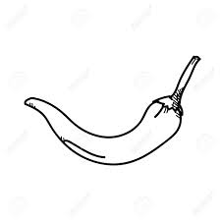 …………………………………………………… .

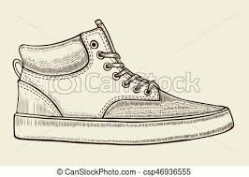 ……………………………………………………. .

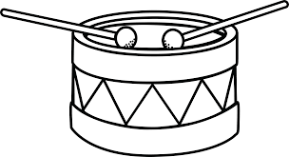 …………………………………………………… .

d)
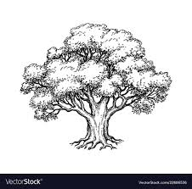 …………………………………………… .

e)
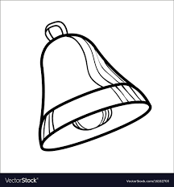 ……………………………………………. .

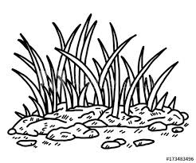 ……………………………………………….. .

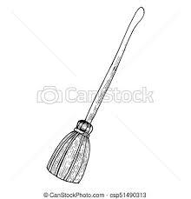 ………………………………………………… .

Q.14) Fill in the blanks with proper words.

- We see it in the night sky. ………………………………………… .

- The biggest land animal. ………………………………………… .

- We love to eat it in hot season. …………………………………………. .

- The first day of the week. …………………………………………… .

